A literature Review: AI Models for Road Safety for Prediction of Crash Frequency & Severity
Main (corresponding) Author
Muneeb Shehzad Butt
Researcher (PHD)
University of Central Punjab Lahore Pakistan
L1s23phdc0003@ucp.edu.pk
00923224865630
Co Author
Muhammad Awais Shafique
Assistant Professor
University of Central Punjab Lahore Pakistan
00923214223020

Abstract:
Artificial intelligence and machine learning have brought a new paradigm in road safety, moving from the traditional approach to adopting data-driven techniques for predicting the frequency and severity of crashes. This review gives the main research contributions and highlights works toward integrating different data sets into one comprehensive safety assessment, starting from traffic patterns, environmental conditions, and driver behavior analytics. This research paper reviews how AI and ML are revolutionizing road safety: from basic statistical methods, such as Ordered Probit, to advanced Neural Networks and Deep Learning techniques. It provides rich detail on the dynamics of crashes to serve as a basis for intelligent traffic management and policy decisions. That's because what has transpired with the confluence of AI, ML, and road safety initiatives is a major step forward to reduce traffic incidents and improve roadway safety, from early statistical models to sophisticated systems capable of predicting crashes and identifying opportunities for intervention. Fig 2
1.0-Introduction:
1.1 Background
Road safety continues to be a major global concern, as traffic accidents remain among the leading causes of injury and death worldwide. Traditional road safety management relies heavily on reactive measures, such as crash reports and historical data analysis, which often lack the predictive capabilities needed to prevent accidents before they occur. The rapid progress in AI and ML offers new opportunities to shift from descriptive and diagnostic approaches to predictive and prescriptive solutions, enabling a more proactive stance in road safety management.
1.2 Problem Statement
Currently, most road safety strategies face significant challenges, including poor data integration, slow response times, and inadequate predictive accuracy. Traditional statistical models, like Ordered Probit models, provide insights into crash severity but miss the complex, non-linear relationships among variables such as traffic flow, weather conditions, and driver behavior. With today’s dynamic road environments, there is a growing need for more sophisticated tools capable of analyzing large datasets in real-time, predicting potential crash hotspots, and guiding timely interventions.
1.3 Research Gap
Despite AI and ML's potential to enhance road safety, there is still a substantial gap in understanding the full capabilities and limitations of these technologies. Current literature often focuses on isolated applications of AI/ML models, such as neural networks for crash prediction or support vector machines for congestion analysis, without providing a comprehensive view of how these models can be integrated into a cohesive safety management system. Additionally, the lack of standardized methodologies and comparative analyses across AI/ML approaches hampers the identification of the most effective strategies for diverse traffic scenarios.
1.4 Objectives of the Review
This review addresses the identified gaps by analyzing the development and impact of AI/ML models in road safety. It highlights key research contributions, compares the effectiveness of various AI/ML techniques, and discusses their integration into real-time traffic management systems. By synthesizing insights from existing studies, this paper aims to demonstrate the transformative potential of AI/ML in reducing crash frequency and severity, guiding future research, and informing policy decisions.
1.5 Paper Organization
The paper is organized as follows:
Section 2 presents a foundational analysis of AI/ML models used in predicting driver injury severity, intersection crashes, and the impact of congestion on road safety.
Section 3 discusses advancements in real-time crash prediction and safety management, focusing on dynamic safety systems and deep learning applications.
Section 4 explores innovations like virtual reality, big data, and IoT integration, highlighting their role in enhancing road safety.
Section 5 examines AI's dual role in ensuring the safety of autonomous vehicles and broader transportation modes.
Section 6 concludes by summarizing the findings, discussing challenges, and suggesting directions for future research in AI-driven road safety.
2.0-Foundational Analysis of Driver Injury Severity, Intersection Crash Prediction and Traffic Congestion
Understanding and predicting road safety outcomes requires highly robust analytical models that can capture the complex interactions between drivers, vehicles, road conditions, and traffic patterns. Such basic models include Ordered Probit, Neural Networks, and other traditional methods used in analyzing the dynamics of crashes, identifying risk factors, and coming up with focused interventions. The general methodologies applied to road safety research are described in the following section, focusing on the way that these models quantify driver injury severity, predict intersection crashes, and analyze the impact of congestion on traffic safety. Understanding these fundamental models helps in ascertaining the strength, limitation, and areas in which prediction ability can be further enhanced in a traffic management system.
2.1-Analyzing Driver Injury Severity with Ordered Probit Models
Ordered Probit Models are commonly utilized in traffic safety research to evaluate the severity of driver injuries influenced by various factors. Abdel-Aty (2003) laid the groundwork by applying these models to diverse traffic scenarios in Central Florida, capturing the complex dynamics of how driver characteristics and vehicle types influence injury outcomes. His work highlights the critical role of in-depth data analysis in identifying specific safety measures, showing how these models can offer key insights into crash severity factors.
Building on this, Chen et al. (2019) expanded the use of Ordered Probit Models by introducing bivariate distributions with random parameters to examine the relationship between driver injuries and individual-specific factors. Their research found that variables like age, gender, vehicle safety features, and environmental conditions significantly affect injury severity. For instance, older drivers, female drivers, and those using older vehicles lacking safety features such as airbags face heightened injury risks. The study also uncovered varying effects of alcohol and drug use in different collision types, stressing the importance of accounting for local crash dynamics when designing preventive strategies.
Together, these studies demonstrate the power of Ordered Probit Models in capturing the subtle interactions among diverse risk factors in crash severity analyses. They also highlight the need for further refinement of these models to address evolving correlations and to explore a wider range of crash types. Insights from these models can guide more effective safety interventions and policy decisions, ultimately aiming to reduce traffic-related injuries
2.2-Neural Networks in Predicting Intersection Crashes
Neural networks have also become useful tools in traffic safety research because of their great capability for modeling complex, non-linear relationships among various crash determinants. Akin et al. (2010) modeled neural network models to predict intersection crashes in Macomb County, Michigan. The results show the prediction accuracy of 90.9%. In this respect, the research presents an opportunity for neural networks to bring together numerous factors pertaining to crashes, including driver behavior, traffic flow, and environmental characteristics and conditions, with a view to better understanding the dynamics of intersection crashes. This is much further than what conventional statistical methods can achieve, which barely cope with the non-linear and interdependent nature of crash variables.
In similar research, the work of Li et al. (2019) suggested a hybrid model that combines a Long Short-Term Memory network and Convolutional Neural Networks to predict real-time crash risks on urban arterials. Their approach also uses the Synthetic Minority Over-sampling Technique in dealing with imbalanced data and integrates traffic flow, signal timing, and weather conditions into the diverse datasets. This model significantly outperforms conventional methods: for example, Bayesian Logistic Regression in key performance metrics, such as sensitivity, false alarm rates, and AUC. Incorporating spatial-temporal features into the model captures complex patterns within traffic data that would be helpful in proactive traffic management.
Li et al. (2019) recognizes that although their hybrid model shows great promise, there is room for improvement through increased architectural complexity and more diverse data sampling techniques. This research illustrates how deep learning models can overcome past limitations, providing a template for future advancements in crash prediction that can adapt to real-time changes in traffic conditions. These developments underscore the transformative potential of AI in traffic safety, offering a data-driven approach to more effective and responsive traffic management systems.
2.3-The Impact of Congestion on Road Safety
Traffic congestion plays a complicated role in road safety, influencing the likelihood and severity of crashes as well as the types of accidents under different traffic conditions. Marchesini et al. (2010) found that speed fluctuations become even more pronounced during congestion, leading to changes in crash severity. Their study suggests that further research using advanced statistical methods that incorporate traffic volume, flow variables, and actual crash data, particularly in urban highway corridors, would be beneficial. This highlights the need for targeted safety interventions on freeways and underscores the importance of comprehensive approaches when considering the complex effects of congestion.
Building on this, Albalate et al. (2021) examined the relationship between congestion and road accident fatalities in 129 major European cities over a decade (2008–2017). Their study used both parametric and non-parametric econometric methods and discovered a complex, U-shaped relationship between congestion levels and road safety. Initially, higher congestion levels reduce road fatalities because slower speeds curb aggressive driving. However, beyond a certain point, when travel times increase significantly, the probability of accidents rises due to erratic driving, speed differentials between vehicles, and an increased likelihood of rear-end collisions.
This research challenges the simplistic view that congestion always improves road safety by slowing traffic. Instead, it shows that the impact of congestion is highly variable and depends on the level of traffic. This nuanced perspective suggests that while moderate congestion may offer some safety benefits, severe traffic jams pose significant risks, calling for specific interventions and further study.

3.0- Advancements in Real-Time Crash Prediction and Safety Management
Advancements in real-time crash prediction and safety management have leveraged AI and big data, revolutionizing how road safety is monitored and managed. This section highlights key innovations in dynamic safety systems, AI-driven traffic management, and computational intelligence in accident detection.
3.1 Dynamic Safety Management Systems Using Real-Time Data
Dynamic safety management systems use real-time data to improve road safety by predicting and mitigating potential crashes. Xu et al. (2013) demonstrated the importance of integrating real-time data by utilizing loop detector data from California’s I-880 to develop models predicting crash likelihood at different severity levels. This breakthrough enabled real-time predictions of severe crashes, allowing for proactive interventions like variable speed limits and ramp metering, showcasing the transformative potential of real-time data in traffic safety.
Kutlimuratov et al. (2023) expanded on this by introducing a real-time vehicle counting system as part of Tashkent’s Smart City project. Using the YOLOv5 model for vehicle detection and Deep SORT for tracking, this system achieved 98.1% accuracy in vehicle counts within 0.2408 seconds, even under varying weather conditions. The research illustrates the use of real-time data to enhance urban transportation, setting the stage for further innovations like recommendation systems and speech recognition integration.
3.2 Enhancing Traffic Safety on Expressways with AI
AI has greatly influenced expressway safety management through predictive modeling. Sun et al. (2014) combined Support Vector Machine (SVM) models with k-means clustering to accurately predict crash probabilities on expressways. By analyzing traffic flow and crash data, this hybrid approach improved the accuracy of crash predictions, emphasizing AI’s critical role in advancing real-time crash prediction systems and integrating sophisticated computational methods into traffic analysis.
Chao et al. (2023) introduced TPASTGCN, a new framework that enhances trajectory prediction for autonomous vehicles at complex intersections. Using attention-based spatial-temporal graph convolutional networks, this approach significantly improved model performance compared to basic models. However, the study suggests that incorporating factors like signal timing and driver behavior could further refine autonomous vehicle navigation for safer urban travel.
3.3 Big Data and Computational Intelligence in Accident Detection
Big data and computational intelligence have transformed accident detection, creating new opportunities for early warning systems and improved traffic safety management. Ozbayoglu et al. (2016) developed an accident-detection system using models like nearest neighbor, regression trees, and neural networks to analyze traffic flow data in Istanbul. Despite high false alarm rates, the system demonstrated the substantial potential of big data in predicting accidents and enhancing emergency response.
Sybil et al. (2019) evaluated SVM and Probabilistic Neural Network (PNN) models for detecting accidents on Chicago’s Eisenhower Expressway within 1 to 7 minutes of occurrence. Using SMOTE to address imbalanced datasets, the study found that SVM generally provided higher accuracy, while PNN excelled in early detection during critical response times. The research highlights the value of diverse data sources and suggests using deep learning techniques like RNN and CNN for improved crash detection in imbalanced datasets.
3.4 Integrating Traffic and Weather Data for Freeway Safety
Combining traffic and weather data offers a novel approach to enhancing freeway safety. You et al. (2017) integrated traffic data from loop detectors with weather information to predict crash likelihood in real time using SVMs, improving prediction accuracy and reducing false alarms. This approach paves the way for enhanced real-time freeway safety management.
Sahu et al. (2020) explored the impact of weather conditions like snowfall and cold temperatures on traffic volumes on provincial highways. Using MIC statistics, the study found complex, non-linear relationships between weather factors and truck traffic flows, highlighting the need for granular data analysis to capture subtle weather effects on traffic dynamics. Incorporating advanced statistical methods can further refine our understanding of environmental impacts on road safety.
4.0 Innovations in Traffic Safety: Real-Time Predictive Analytics and Management
In recent years, advancements in traffic safety have been bolstered by real-time predictive analytics and management tools that leverage AI, machine learning, and immersive technologies. From predicting crash risks to utilizing virtual reality for driver training, these innovations are reshaping our approach to safer roadways.
4.1 Virtual Reality and Navigation for Road Safety Improvement
The intersection of virtual reality (VR) and augmented reality (AR) has opened new possibilities for road safety. Eliseev et al. (2018) introduced an interactive VR/AR system that provides real-time information about hazardous areas and simulates emergency scenarios. Initially implemented in Nizhny Novgorod, Russia, this system aims to enhance driver awareness and improve navigation by immersing road users in realistic training scenarios. By simulating potential hazards, drivers gain experience that can translate to safer driving in real-world situations.
Similarly, Ojeda et al. (2018) explored VR training for conditionally automated vehicles using head-mounted displays. Their study found that VR-based training methods significantly improve drivers’ response times and takeover behaviors compared to traditional methods like manuals or stationary simulators. This research positions VR as an effective and affordable training tool, enabling drivers to adapt more smoothly to autonomous vehicle operations. Future developments might even include custom VR programs to meet individual training needs, further enhancing drivers' abilities to navigate modern traffic environments.
4.2 The Evolution of Real-Time Crash Prediction Models
In the realm of predictive analytics, Abdel-Aty (2018) delves into Real-Time Crash Prediction Models (RTCPMs), which utilize AI, sensor fusion, and advanced algorithms to proactively manage traffic safety. By integrating autonomous and connected vehicle technologies, these models represent a shift towards preemptive safety measures. Abdel-Aty’s work provides a roadmap for RTCPM development, emphasizing the need for robust models that can evolve with technological advancements. By bridging the gap between theory and practical applications, his research holds promise for reducing crash incidences on a larger scale.
4.3 Analyzing Crash Severity Risk Factors
The complexities of crash severity are dissected in a review by Safari et al. (2019), who identified key demographic, behavioral, and environmental factors contributing to accident risks. This study groups risk factors into five categories and 47 sub-variables, offering actionable insights for policymakers aiming to reduce road fatalities. Complementing this work, Wang et al. (2023) studied accidents in Shenyang, China, using Random Forest and SHAP techniques to analyze 19 risk factors, such as Points of Interest (POI) density and road type. Their findings reveal a strong correlation between high POI density and increased accident severity, highlighting the importance of targeted urban planning to mitigate crash risks.
4.4 AI's Transformative Role in Transportation
AI’s transformative role in transportation is evident in Abduljabbar et al. (2019), who discuss how advanced computational techniques like artificial neural networks (ANNs), genetic algorithms (GAs), and fuzzy logic models (FLMs) are shaping urban mobility and traffic management. AI not only helps manage travel demands but also contributes to safety improvements across the transportation sector. Similarly, Xiaoyi Hu (2024) explores the future of autonomous vehicles and the rapid growth of AI, particularly in China, where commercialization of driverless technologies is well underway. These advancements in AI promise a future with enhanced traffic efficiency, inclusivity, and sustainable mobility options.
4.5 The Dual Role of AI in Autonomous Vehicle Safety
With autonomous vehicles (AVs) advancing, Nascimento et al. (2019) and Abbasi et al. (2023) explore AI's dual role in AV safety, especially in machine perception and system design. They highlight the need to incorporate human factors into AV systems to ensure a comprehensive approach to safety. Their work advocates for robust research into fault tolerance and system reliability, acknowledging the complexities of ensuring AV safety in real-world settings. Such research provides a foundation for integrating AI that not only advances AV technology but also addresses key safety concerns.
4.6 Data Mining Approaches to Road Accident Analysis
Data mining is increasingly used to analyze accident data, identify patterns, and inform safety measures. Narwadkar et al. (2020) demonstrate the effectiveness of clustering and association rule mining in uncovering accident-prone scenarios, supporting targeted interventions to improve road safety. Similarly, Dias et al. (2023) used data mining to analyze accident data in Portugal, revealing patterns like peak accident times (5:00-8:00 p.m.) and high-risk factors like rain and Fridays. They emphasize the need for tailored safety strategies based on road type and location.
5.0 Revolutionizing Road Safety: How AI and Emerging Technologies are Making an Impact
Artificial Intelligence and Machine Learning have immense power in transforming road safety by offering predictive, real-time insight into a variety of transportation modes. The contribution of such technologies extends from intelligent transportation systems to the detection of incidents in real time with a view to making transport ecosystems efficient and safe. This section looks at some novel uses of AI and emergent technologies in assuring traffic safety, predictive analytics, and safety assessment.
5.1 AI in Integrated Transportation Safety
Artificial intelligence applications are increasingly used in road, air, and rail transport, with the view of achieving integrated systems that enhance safety and operational efficiency. Tselentis et al. (2020) identified an integrated approach whereby AI applies across transportation modes for overall security enhancement and operational smoothness. Bharadiya (2023) identified AI's application as one of the key intelligent transportation systems that form the basic elements of smart city development. Such technologies therefore help in optimizing urban infrastructure and traffic management towards safe and efficient cities.
The role of AI, VR, and mining of data in shaping the face of traffic safety is endless, and their potential in reducing accidents and improving driver awareness is an ever-growing revolution in how we manage and prevent incidents.
5.2 Predictive Analytics across Transport Choices
Predictive analytics also provide rich insights to decision-makers in understanding transportation mode preferences, travel efficiency, and choice of transport solutions. Shafique et al. (2021) proposed a hybrid approach for including the Multinomial Logit model with weighted random forest algorithms within high-accuracy predictions of choices of travel mode on data from smartphone sensors. The contribution encourages the incorporation of socio-economic variables for expanding the presented model to various transportation modes. Qian et al. (2021) developed the SVMAK algorithm, incorporating Support Vector Machine with tunable kernel scaling theory for processing class-skewed data in transportation planning. Based on the 2017 National Household Travel Survey, the model was performing well with a better classification of transport modes, in particular, the minority classes, with better rebalancing of their class boundaries through weighted chi-square tests.
Sensitivity analysis in the study determined that factors affecting mode choice key to walking limitations and count of drivers in the household. The high metric performance of accuracy of the SVMAK thus established its usefulness in classifying the travel choices in a proper manner, which may go further to include the car travels in addition to these imbalanced datasets.
5.3 IOT and AI in the Development of Road Safety
With the increase in the number of vehicles on the roads, managing the traffic congestion and ensuring road safety have become increasingly complex processes. Kumar et al. (2020) look upon AI and the IoT as the backbone for intelligent support in road safety management. The proposed SRTMS will enable the real-time monitoring of road safety by integrating AI with the IoT in detecting the patterns which may lead to dangerous driving conditions, identifying the risks, and warning in time.
Blockchain (BC) technology further enhances SRTMS by enabling secure data sharing between IoT devices, contributing to efficient, decentralized traffic management.
Bhattacharya et al. (2022) elaborate on IoT in safer travel by delivering real-time updates and the application of AI in driver behavior monitoring and the evaluation of road conditions. Their combined effort, IoT and AI, culminates into a proactive safety ecosystem for developing automated vehicles and other intelligent transportation solutions. Fig 1,
5.4 AI and ML for Incident Detection in Road Transport
In summary, AI and ML technologies have further enhanced incident detection systems in road transport, making highways much safer and, hopefully, improving emergency response times. Olugbade et al. illustrate the potentials of AI in traffic monitoring regarding route planning, flow traffic optimization, and the enhancement of road safety. These integrate with other sources of data towards improving predictive accuracy and real-time decision-making. Alsharif et al. proposed an advanced real-time traffic incident detection system in Saudi Arabia that enhances the efficacy of emergency responses. The system detects traffic incidents with high accuracy in three different AI-based model tasks: vehicle detection using YOLOv5, accident severity classification using fast YOLOv5, and fire detection using ResNet152. The overall performance reached 99.2% mean average precision for detecting objects, 83.3% for classifying the severity, and 98.9% for fire detection.
Due to parallel computing, this method reduces processing time, hence it is applicable in high-traffic flow areas and enhances existing surveillance infrastructures.
5.5 Traffic Safety Analysis - Deep Learning's Role
Deep learning techniques are increasingly applied in traffic safety to support accurate short-term traffic forecasting and safety metric analysis. Manibardo et al. (2021) conducted a critical review of applications in DL for ITS, considering more than 150 studies. Even though DL techniques are a good fit for complex, heterogeneous data, the research outcome indicates that advantages over traditional models are inconsistent for all applications; hence, there is a need for more refined methodologies and comparative studies.
Razi et al. (2022) investigates the capability of DL to analyze traffic safety through performing video-based extraction of safety metrics. It also underlines how versatile DL has been with respect to handling large-scale datasets, thus underpinning future research directions within a fully deployed real-world transport environment.
5.6 AI for Safety Assessment Across Transport Modes AI is playing a transformative role in assessing the safety of different transportation modes. Sahin et al. (2022) proposed a k-shot learning algorithm that achieved Transportation Mode Identification using wearable device data, which allowed the system to recognize not only familiar but also new transport modes, such as cars, buses, and trains.
Testing the algorithm on real-world data, the 13 participants and 15 sensors came out with highly accurate results of 89.46% to 93.94%, hence great potential for application in urban planning, targeted advertising, and sustainable transport solutions.
Tselentis et al. (2023) considered AI and ML applications for improving safety and efficiency within various modes of transport and emphasized the point that "more effort needs to go into place towards adapting these ever-evolving technologies." Their findings bring into focus the role of AI, ML, IoT, and DL in establishing a safer, more efficient, and connected transportation ecosystem that may reach into all aspects of urban mobility and traffic management.
6.0 Conclusion: Marching into the Future of Transportation Safety with AI and ML.
The integration of Artificial Intelligence and Machine Learning in transport safety represents a sea change in roadway causalities and efficiency improvements in worldwide transportation. From real-time crash prediction models and IoT-enabled safety management, using deep learning for traffic flow analysis, these technologies mark a paradigm shift toward making transportation safety data-driven and proactive.
These studies reviewed emphasize that AI and ML have the potential to help in reducing both the frequency and severity of accidents while allowing for very specific preventive interventions based on insights driven by data.
However, all this potential of AI and ML in transportation has a lot of challenges. The challenges regarding data integrity, cybersecurity, and ethical considerations in the use of autonomous vehicles and ADAS demand special handling. Secondly, this full exploitation of benefits requires cross-modal exchange of knowledge, integration of emerging concepts into safety assessments, especial emphasis on interdisciplinary collaboration, and innovation.
These applications have already demonstrated paradigm shifts in transport safety-from k-shot learning for transportation mode identification to real-time incident detection. Predictive analytics on incidents, incident detection, and infrastructure maintenance are areas of key future advancements that can reshape transportation safety. With more autonomous vehicles coming up and evolving infrastructures into smart ones, a future with adaptive and data-centric road transport safety increasingly appears within reach.
It therefore follows that the integration of AI and ML into transportation safety initiates a new frontier of risk management with a pre-active approach, balancing technological advancements with social needs for safer mobility. This will be further developed by continuous exploration and refinement to help safeguard road users and ensure a sustainable, secure future for transport systems worldwide.
However, apart from summarizing the different AI models, some critical evaluation is done about each model's strengths and/or weaknesses to balance the practicality of their scope in road safety applications. This paper develops a more critical analysis that will identify what is important related to the particular contributions of each model and multiple challenges entailed for a preliminary view into their applicability to various traffic scenarios and safety interventions. (Table 1)
1. Advanced Logit and Probit Models in Crash Severity Analysis
Contributions: Advanced logit and probit models have significantly enhanced crash severity analysis in a wide range of studies. For instance, Abdel-Aty (2003) points out the effectiveness of Ordered Probit Models in the assessment of driver injury severity in different traffic conditions. These models give valuable information regarding the impacts of demographic factors—age and sex—along with vehicle attributes on crash severity. Through the determination of influential risk factors, these models facilitate researchers and policymakers to implement evidence-based safety measures that minimize crash severity and enhance road safety.
Limitations: While they are useful, they have certain limitations. Their linearity inherently restricts the ability to model complex, nonlinear relationships between variables, reducing the accuracy of the model to forecast situations with interaction effects or nonlinear trends. Another key problem with crash severity modeling is the unbalanced nature of the data since severe crashes happen much more infrequently than minor ones. The unbalance potentially results in model performance bias, complicating the effective forecasting and analyzing of severe crashes. To solve these problems, more advanced modeling methodologies—such as random parameter logit models and machine learning techniques—are needed since they offer more flexibility to model nonlinearity and address data unbalance in crash severity modeling.
2. Neural Networks for Intersection Crash Prediction
Contributions: Akin et al. (2010) used neural networks to accurately predict intersection crashes at 90.9%. This model showed that the neural networks could handle nonlinear interaction between crash determinants, driver behavior, and environmental factors and offered a perfect suite for crash prediction tasks in a complex environment.
Limitations: Neural networks are hungry for training data, and it may be difficult to collect it for particular intersections or special kinds of crashes. They also easily suffer from overfitting when applied to small or imbalanced datasets. Neural networks are black boxes, interpretation is hard, hence considerably reducing the model transparency for policy implications and practical implementation.
3. LSTM-CNN Hybrid Model for Real Time Crash Prediction
Contributions: Li et al. (2019) proposed a hybrid model that integrated LSTM networks with CNNs to predict real-time crash risks on urban arterials. Specifically, this hybrid model leverages sequential data to capture the temporal pattern in the occurrences of crashes, while the CNN components process the spatial features and thus provide a robust framework for essential real-time traffic safety applications.
Limitations: However, these are limited by the fact that the hybrid model is somewhat computationally expensive and thus not practical in use at every location due to limited technological infrastructure. The complexity in model architecture further involves extensive hyperparameter tuning, which is resource-consuming. Sensitivity to the quality and balancing of data remains one major limitation of this model as applied to rare events such as crashes across diverse traffic scenarios.
4.Expressway Safety using Support Vector Machines (SVM)
Contributions: Sun et al. (2014) applied Support Vector Machine models coupled with k-means clustering to forecast probabilities of crashes on expressways, where such models show their strength in high-dimensional data settings. This study thus reiterated that SVM was particularly useful when one had balanced datasets and interpretability was not as critical as predictive accuracy.
Limitations: SVMs usually perform not as good in the case of very large and highly unbalanced datasets. The tuning of kernel parameters may be cumbersome; SVM models also require more computational resources than the simpler models. The approach may also lack interpretability when there is a need for policy and safety measures with explicitly defined casual factors.

5.Random Forest for the Analysis of Risk Factors in Crash Severity
Contributions: Wang et al. have estimated the significant contributing factors to crash risk using Random Forest ensembled with SHAP techniques, hence offering valuable insights into demographic and environmental factor contributions toward crash severity. Random Forest has the capability for handling missing data and determine feature importance, thus providing advantages in exploratory analysis.
Limitations: The limitations are that Random Forest can be relatively easier to interpret compared to neural networks, though it cannot capture temporal dependencies yet. It can also be computationally expensive where there may be a big dataset. Second, Random Forest may not be so effective on highly imbalanced datasets, which may further skew the feature importance metrics and result in high emphasis on majority classes.
6.Deep Learning in Traffic Forecasting
Contributions: Manibardo et al. (2021) critically reviewed deep learning applications in traffic forecasting, concluding that while DL models can manage complex heterogeneous data sets, they did not universally outperform all other models across all road safety applications. This review helps to establish a basis for when DL adds value, especially in short-term traffic forecasting and dense data environments.
Limitations: These models, however, are computationally expensive and require substantial computational resources for training and deployment. Most deep learning models are of a black-box nature and hard to interpret; they restrict transparency and usability in policy applications. Moreover, the performance of DL may be uneven depending on specific traffic scenarios, model architecture considered, and quality of data.
7.K-Nearest Neighbors for Early Accident Detection
Contributions: Ozbayoglu et al. applied K-Nearest Neighbors to accident detection, showing its applicability based on simple and efficient earlystage predictions. This model is especially suitable for smaller, well-structured datasets where it has high interpretability and ease of implementation.
Limitations: The limitations are thereby stated: First, it does not work well for high-dimensional data, and for large datasets, it becomes computationally expensive. Further, KNN is sensitive to irrelevant features; hence, feature selection becomes very important, which once again limits its scalability and robustness in broad applications concerning road safety.
8.Driver Training by Virtual Reality
Contributions: Eliseev et al. (2018) were able to prove that drivers are more aware, and their response time is much better in hazardous situations created with VR training. VR training creates an enhanced environment for the driver to experience and react to high-risk situations without real-world consequences, instilling safe driving behavior in them.
Limitations: The use of VR on a wide scale, apart from the need for specialized hardware, is expensive. It may be further affected by the novelty effect; thus, it has been observed that performance during the training cycle is better than the on-road driving conditions. Further, the existing constraints on the use of VR are that, so far, it has been used only in training and not applied directly on the spot.
A comparative analysis of various AI approaches for crash prediction, highlighting their accuracy, training time, interpretability, and computational cost to aid in selecting the most suitable model for real-time applications has been generated for review. Fig 3.
10-Future Implications
1- Balancing Protection of Privacy and Security in Autonomous Vehicles and AI Surveillance Systems
With the development of autonomous driving and artificial intelligence-driven surveillance systems, society is faced with an urgent question: how to balance the need for safety with the protection of individual privacy. As real-time data collection and AI-powered surveillance enhance road safety and streamline traffic management, they also raise concerns about data security, individual privacy, and government intrusion. Key Considerations are
Regulatory Compliance: Autonomous driving and AI surveillance technologies must comply with international privacy laws such as the General Data Protection Regulation (GDPR) in the European Union and the California Consumer Privacy Act (CCPA). These laws outline how data should be collected, stored, and used while ensuring user consent is obtained.
Data Anonymization: Implementing robust data anonymization techniques can protect personally identifiable information (PII) without compromising the effectiveness of AI systems in accident prediction and prevention.
Public Trust and Transparency: Building public confidence in AI technologies requires transparency in how surveillance data is collected, stored, and used. Clear policies on who has access to data and how decisions are made can help foster greater trust in these systems.
Responsible AI Development: AI models used in autonomous vehicles and surveillance systems must be designed to avoid perpetuating bias or disproportionately impacting certain communities. Establishing ethical AI frameworks can help guide the fair and accountable development of machine learning models.
2-Aligning Technological Progress with Societal Needs
The implementation of Intelligent Transportation Systems (ITS) and Autonomous Vehicles (AVs) depends not only on technological advancements but also on public acceptance. Resistance to these new technologies often stems from concerns about safety, job displacement, and economic disparities. To ensure a smooth transition, policymakers must actively engage with communities and stakeholders. Major Strategies are
Public Education and Engagement: Governments and industry leaders must invest in public awareness campaigns that inform citizens about the benefits and limitations of ITS and AVs.
Gradual Rollout: A phased approach, such as mixed-use roadways where autonomous and human-driven vehicles coexist, can help ease societal adaptation and build public trust over time.
Economic and Employment Impact: Addressing concerns about job displacement in traditional transportation sectors is crucial. Reskilling programs can help workers transition into AI-driven industries and maintain employment opportunities.
Fairness, Accountability, and Transparency in AI: Ethical deployment of AI in transportation should prioritize fairness and ensure that the benefits of these advancements are equitably distributed across different socioeconomic groups.
By proactively addressing privacy concerns, fostering public trust, and ensuring ethical AI development, autonomous driving and AI surveillance systems can be safely and responsibly integrated into society.

,

AI Model | Advantages | Limitations | Applications in Road Safety
Ordered Probit Model | - Handles ordinal data well | - Limited to linear relationships | - Evaluating driver injury severity
Ordered Probit Model | - Allows for interpretation of factor impacts on crash severity | - Struggles with complex, non-linear data | - Identifying risk factors influencing crash outcomes
Neural Networks | - Excellent for modeling complex, non-linear relationships | - Requires large datasets | - Predicting crash occurrences at intersections
Neural Networks | - High predictive accuracy | - Prone to overfitting without regularization | - Analyzing driver behavior and traffic patterns
Long Short-Term Memory (LSTM) | - Effective in handling sequential and temporal data | - Computationally intensive | - Real-time crash prediction in arterial networks
Long Short-Term Memory (LSTM) | - Works well with time-series forecasting | - Requires balanced datasets for optimal performance | - Integrating weather, traffic, and signal timing for proactive safety
Support Vector Machine (SVM) | - Robust to overfitting with proper parameter tuning | - Struggles with large datasets | - Predicting crash probabilities on expressways
Support Vector Machine (SVM) | - Works well with high-dimensional data | - Limited interpretability in complex applications | - Real-time freeway and expressway safety management
Random Forest | - Provides variable importance | - Limited in handling sequential data | - Analyzing risk factors in crash severity
Random Forest | - Handles missing data well | - May struggle with highly imbalanced datasets | - Studying accident likelihood in various traffic conditions
Deep Learning (DL) | - Suitable for complex, heterogeneous datasets | - Black-box nature limits interpretability | - Short-term traffic forecasting
Deep Learning (DL) | - High accuracy in large-scale data contexts | - High computational requirements | - Real-time accident detection in high-density traffic
K-Nearest Neighbors (KNN) | - Simple and effective for small datasets | - Poor performance with high-dimensional data | - Early accident detection using traffic flow data
K-Nearest Neighbors (KNN) | - Good for early accident detection | - Sensitive to irrelevant features | - Initial screening in predictive safety models
Virtual Reality (VR)/AR | - Offers immersive training environments | - Expensive setup for large-scale training | - Driver training for emergency response
Virtual Reality (VR)/AR | - Improves driver reaction through simulations | - Limited application to real-time scenarios | - Simulation of hazardous situations for driver preparedness
Table 1: Comparative Analysis of AI Models in Road Safety: Advantages, Limitations, Applications
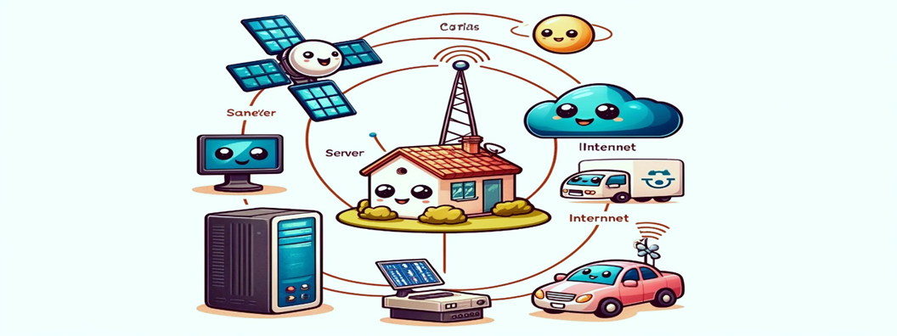

Fig 2: Internet of Things (IOT)
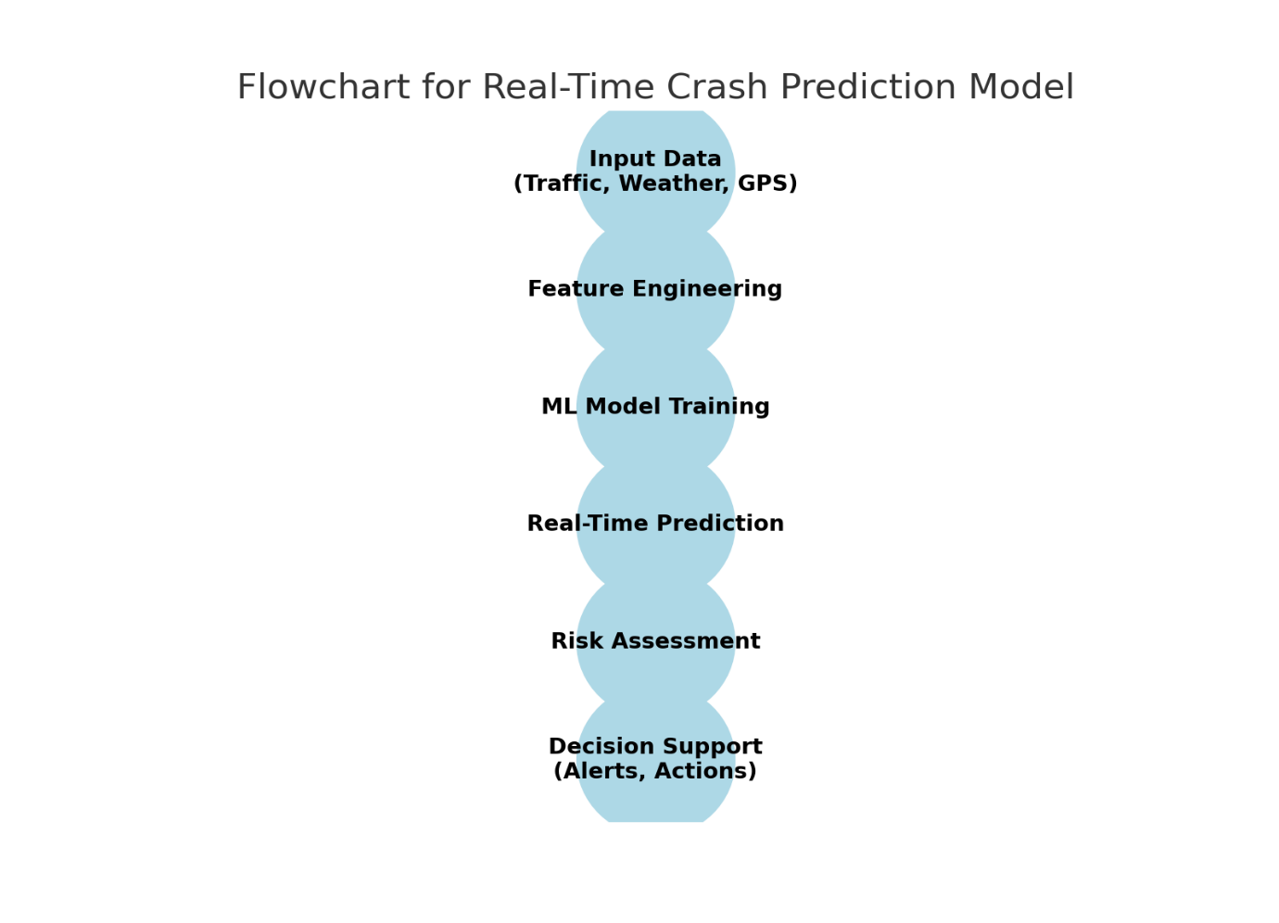

Fig 1: Flow Chart for Real Time Crash Prediction Model.
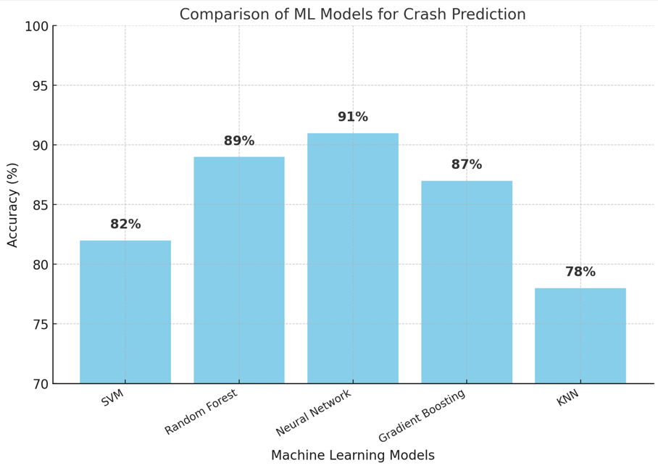
Fig 3: Machine Learning Models accuracies

Declarations
Ethical Approval
This research does not involve human or animal subjects and, therefore, did not require ethical approval from an Institutional Review Board or Ethics Committee.
Authors' Contributions
Muneeb Shehzad Butt: Conceptualization, methodology design, data analysis, manuscript writing, and editing.
Muhammad Awais Shafique: Supervisory role, guidance in the review of AI models, critical revisions for intellectual content, and final approval of the manuscript.
Competing Interests
The authors declare that they have no financial or non-financial competing interests related to this research.
Funding
No specific funding was received for this research. The study was conducted independently by the authors without external funding sources.
Availability of Data and Materials
The data supporting the findings in this study are available from public repositories, as detailed within the manuscript. Further data used or generated in this study are available upon reasonable request from the corresponding author.

Muneeb Shehzad Butt
Corresponding Author
L1S23PHDC0003@ucp.edu.pk

References:
- Abdel-Aty, M. (2003). Analysis of driver injury severity levels at multiple locations using Ordered Probit models. Journal of Safety Research, 34(5), 597–603.
- Akin, D., & Akbas, B. (2010). Prediction of traffic accidents using Artificial Neural Networks (ANNs). Scientific Research and Essays, 5(19), 2875–2880.
- Marchesini, P., & Weijermars, W. (2010). The relationship between road safety and congestion on motorways. SWOV Institute for Road Safety Research.
- Xu, C., Liu, P., Wang, W., & Li, Z. (2013). Predicting crash likelihood and severity on freeways with real-time loop detector data. Accident Analysis & Prevention, 57, 30–39.
- Sun, J., & Sun, J. (2016). Real-time crash prediction on urban expressways: Identification of key variables and a hybrid support vector machine model. IET Intelligent Transport Systems, 10(5), 331–337.
- Ozbayoglu, A. M., Gudelek, M. U., & Sezer, E. A. (2016). A real-time autonomous highway accident detection model based on big data processing and computational intelligence. IEEE International Conference on Big Data, 1807–1813.
- You, R., Ding, C., & Chen, H. (2017). Real-time traffic accident prediction on freeway using data mining techniques. Journal of Modern Transportation, 25(2), 116–123.
- Eliseev, A. V., Isupova, V. A., & Pukalchik, M. A. (2018). Interactive system for road safety improvement using virtual and augmented reality. IOP Conference Series: Materials Science and Engineering, 386, 012027.
- Abdel-Aty, M., et al. (2018). Real-time crash prediction models: State-of-the-art, design pathways, and requirements. Accident Analysis & Prevention, 124, 66–84.
- Feng, C., et al. (2019). Investigation on the injury severity of drivers in rear-end collisions between cars using a random parameters bivariate ordered probit model. International Journal of Environmental Research and Public Health, 16(14), 2632.
- Safari, M., et al. (2019). A comprehensive review on risk factors affecting crash severity. Iranian Journal of Health, Safety & Environment, 6(4), 1366–1376.
- Li, et al. (2019). Real-time crash risk prediction on arterials based on LSTM-CNN. Accident Analysis & Prevention, 135, 105371.
- Albalate, D., et al. (2019). Congestion, road safety, and the effectiveness of public policies in urban areas. Sustainability, 11(18), 5092.
- Sybil, D., et al. (2019). Real-time accident detection: Coping with imbalanced data. Accident Analysis & Prevention, 129, 202–210.
- Abduljabbar, R., et al. (2019). Applications of artificial intelligence in transport: An overview. Sustainability, 11(1), 189.
- Nascimento, et al. (2019). Systematic literature review on the impact of artificial intelligence on autonomous vehicle safety. arXiv preprint arXiv:1904.02697.
- Sahu, P. K., Singh, S. K., & Singh, A. K. (2020). A new approach to exploring the relationship between weather phenomena and truck traffic volume in the cold region highway network. Modeling, 10, 122–133.
- Girma, et al. (2020). Deep learning with attention mechanism for predicting driver intention at intersections. arXiv preprint arXiv:2006.05918.
- Li, et al. (2020). A hybrid machine learning model for predicting real-time secondary crash likelihood. Accident Analysis & Prevention, 165, 106504.
- Kumar, et al. (2020). The role of blockchain, AI and IoT for smart road traffic management system. IEEE India Council International Subsections Conference (INDISCON). https://doi.org/10.1109/INDISCON50162.2020.00065
- Manibardo, et al. (2020). Deep learning for road traffic forecasting: Does it make a difference? arXiv preprint arXiv:2012.02260.
- Barodi, et al. (2021). An enhanced artificial intelligence-based approach applied to vehicular traffic signs detection and road safety enhancement. Advances in Science, Technology and Engineering Systems Journal, 6(1), 672–683.
- Albalate, et al. (2021). Relationship between congestion and road safety in cities. Transport Policy, 105, 145–152.
- Lei, et al. (2021). Crash prediction on expressway incorporating traffic flow continuity parameters based on machine learning approach. Journal of Advanced Transportation, Article ID 8820402.
- Qian, et al. (2021). Classification of imbalanced travel mode choice to work data using adjustable SVM model. Applied Sciences, 11, 11916.
- Nanda, et al. (2022). Application of IoT and artificial intelligence in road safety. Interdisciplinary Research in Technology and Management (IRTM).
- Cheema, et al. (2022). Data-driven approaches for road safety: A comprehensive systematic literature review. Safety Science, 158(2), 105949.
- Flynn, D. F. B., Gilmore, M. M., & Sudderth, E. A. (2022). Using crowdsourced data to improve models of traffic crash propensity: Tennessee Highway Patrol case study. Journal of the Transportation Research Board, 2676(8), 267–278.
- Olugbade, et al. (2022). A review of artificial intelligence and machine learning for incident detectors in road transport systems. Mathematics and Computers in Simulation, 27, 77.
- Razi, et al. (2022). Deep learning serves traffic safety analysis: A forward-looking review. IET Intelligent Transport Systems, 50(1), 22–71.
- Sahin, et al. (2022). A k-shot learning algorithm for transportation mode identification. Journal of Urban Mobility, 2(2), 53–62.
- Wang, et al. (2023). Analyzing the risk factors of traffic accident severity using a combination of Random Forest and association rules. Applied Sciences, 13, 8559.
- Kutlimuratov, et al. (2023). Applying enhanced real-time monitoring and counting method for effective traffic management in Tashkent. Sensors, 23, 5007.
- Abbasi, et al. (2023). Artificial intelligence and software modeling approaches in autonomous vehicles for safety management: A systematic review. Information, 14, 555.
- Bharadiya, J. (2023). Artificial intelligence in transportation systems: A critical review. American Journal of Computing and Engineering, 6(1), 35–45.
- Wu, L., et al. (2023). Trajectory prediction for autonomous driving using spatial-temporal graph attention transformer. IEEE Transactions on Intelligent Transportation Systems, 23(11), 22343–22353.
- Dias, et al. (2023). The prediction of road-accident risk through data mining: A case study from Setúbal, Portugal. Informatics, 10(1), 17.
- Alsharif, et al. (2024). A real-time computer vision-based approach to detection and classification of traffic incidents. Big Data and Cognitive Computing, 7, 22.
- Behboudi, N., et al. (2024). Recent advances in traffic accident analysis and prediction: A comprehensive review of machine learning techniques. arXiv preprint arXiv:2406.13968.
- Zhang, Z., et al. (2024). Exploring spatial heterogeneity in factors associated with injury severity in speeding-related crashes: An integrated machine learning and spatial modeling approach. Accident Analysis & Prevention, 206, 107697.
- Yang, C., et al. (2025). A machine learning approach to understanding the road and traffic environments of crashes involving driver distraction and inattention (DDI) on rural multilane highways. Journal of Safety Research, 92, 14–26.

